Commands

1. **To Run Zookeeper**
   1. zookeeper-server-start.bat <root>/etc/kafka/zookeeper.properties
2. **To Run Kafka Broker**:
   1. kafka-server-server.bat <root>/etc/kafka/server.properties
3. **To Create Topic**
   1. kafka-topic.bat --create --topic <name> --partitions <#> --replication-factor <#> bootstrap-server <comma-list>
4. **To Run Kafka Console Producer**
   1. kafka-console-producer --topic --broker-list <comma-list> < <Data-file>
5. **To run Kafka Console Consumer**
   1. kafka-console-consumer --topic --bootstrap-server <comma-list> --from-beginning

9. Installing Single Node Kafka Cluster

1. Download Community Version from Confluent.io
2. 
3. 
4.   
   Till now, we downloaded Community Edition of Confluent. It also provides Commercial Edition too.

1. Let’s start Kafka Server/Cluster which is Two-Step Process.
2. **Step 01**: Starting Zookeeper Server.  
     
   



* + 1. **rem Classpath addition for LSB style path**

**if exist %BASE_DIR%\share\java\kafka\* (**

**call :concat %BASE_DIR%\share\java\kafka\\***

**)**



1. **Step 02**: Run Kafka Broker.  
     
   Great!!! We created Single-Node Kafka Cluster.



1. We will use this script to do anything with a topic 🡺 
2. Command to create Topic 🡺   
   
3. **Command options**:
4. **--create** : To create a topic.
5. **--partition**: To specify the partition #.
6. **--replication-factor**: # of copies for each partition.
7. **--bootstrap-server**: a subset of Kafka Brokers for Kafka Clients (Producer & Consumer) to connect initially with Kafka Cluster’s Brokers.



1. We will use this script to send data from console to Kafka Cluster.  
   
2. Command to read and send a Data File to Kafka Server.



1. Command to consume msgs from Kafka Server.  
   

11. Installing a Multi-Node Kafka Cluster

1. 
2. 
3. 
4. 
5. Create 2 more copies of the above file as we have total now 3 nodes.  
   
6. Let’s make changes related to properties 🡺 **broker.id**=0, **listeners**=PLAINTEXT://:9092, **log.dirs**=/tmp/kafka-logs-0 🡨 Where partition data is stored.

|  |  |
| --- | --- |
| 1st Broker Configuration |  |
|  | Broker.id=0 |
|  | **listeners**=PLAINTEXT://:9092 |
|  | **log.dirs**=/tmp/kafka-logs-0 |
| 2nd Broker Configuration |  |
|  | Broker.id=1 |
|  | **listeners**=PLAINTEXT://:9093 |
|  | **log.dirs**=../tmp/kafka-logs-1 |
| 3rd Broker Configuration |  |
|  | Broker.id=2 |
|  | **listeners**=PLAINTEXT://:9094 |
|  | **log.dirs**=../tmp/kafka-logs-2 |

1. Let’s start zookeeper but before that let us clean data sent earlier.   
   Go to c:/tmp/ 🡸 Delete everything.   
   Now run zookeeper.   
   zookeeper-server-start.bat <root>/etc/kafka/zookeeper.properties
2. Now run all three brokers  
   kafka-server-start.bat server-0.properties

kafka-server-start.bat server-1.properties

kafka-server-start.bat server-2.properties  
  
For each broker, a kafka-log-x directory will be created.

1. Now run kafka console producer & consumer.  
   kafka-console-producer --topic <name> --broker-list <list>  
   kafka-console-consumer --topic <name> --bootstrap-server <list>

12. Using Consumer Groups

1. 
2. **Agenda**: We already have 3-Node Cluster. Let us do
   1. A topic with 3 partitions.
   2. Two consumers in a consumer group.
   3. Start Producer and Consumer.
3. Create Topic with 3 partitions.  
     
   Starting a consumer .  
   This option **--group < name>** is important when starting multiple consumers in a same group. Starting another consumer in the same group 🡺 **--group <same-name>**  
   **NOTE: Multiple consumers cannot read from same partitions.**  
   Starting Kafka Console Producer and passing CSV file having **1097 records**.  
   **Brief**: We have ZooKeeper up, three Brokers Up, three partitions, Two consumers in the same group.
4. This is what will happen after starting kafka console producer above.  
   Consumer one has been assigned two partitions and consumer 2 has been assigned one partition.  
   
5. 

**NOTE**: Total = 1244 + 663 = 1907



1. Let’s see the Data Directory for each Kafka Broker where partition directory is maintained.
2. 
3. 
4. 
5. 
6. Let’s use the tool **kafka-dump-log.bat**

**Dumping Partition Data from Broker with broker.id=0**

1.   
   You can dump the data itself too. But we’re skipping.
2. Let’s dump the other partitions’ log.  
   **Dumping partition data from broker with broker.id=1**   
     
   **Dumping partition data from broker with broker.id=2**

13. Configuring Your Development IDE

1. double dot means relative path to the location where we are running script.
2. 
3. 
4. 
5. 
6. 
7. 
8. 
9. 
10. 
11. 
12. 

22. Zookeeper in Kafka

1. ZNODE = Ephemeral Node representing active session for Broker.  
   Let’s see how to start zookeeper and go inside its DB to list all ephemeral node = ZNODE.  
   First start zookeeper as you start when run command zookeeper-shell.bat localhost:2181 to connect with zookeeper’s DB. Then Run ls command to see active brokers as shown below.  
   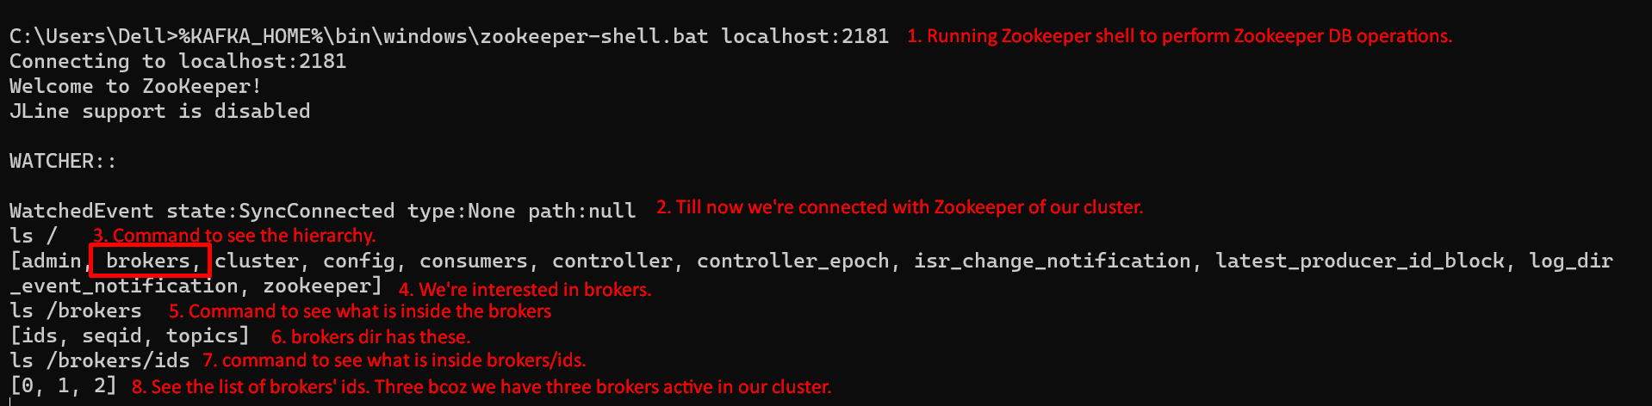  
   

23. Kafka Cluster Controller

1. 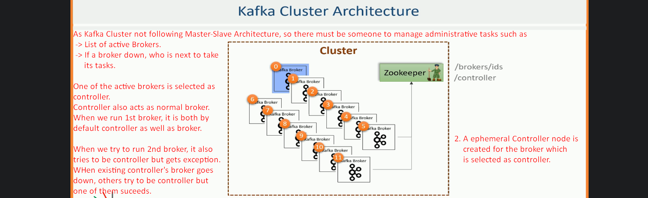
2. Commands to see selected controller.  
     
     
   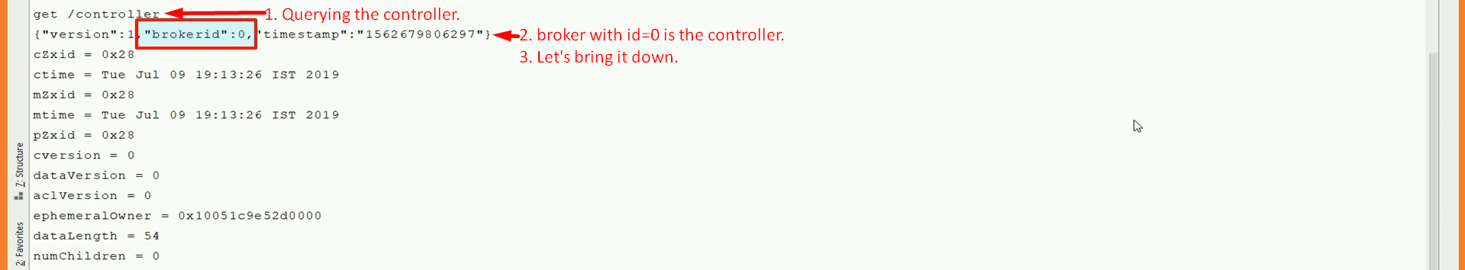  
     
     
     
     
     
     
   

30. Creating Your First Kafka Producer

1. **Agenda**:
   1. Mechanism behind sending events to Apache Kafka.
2. 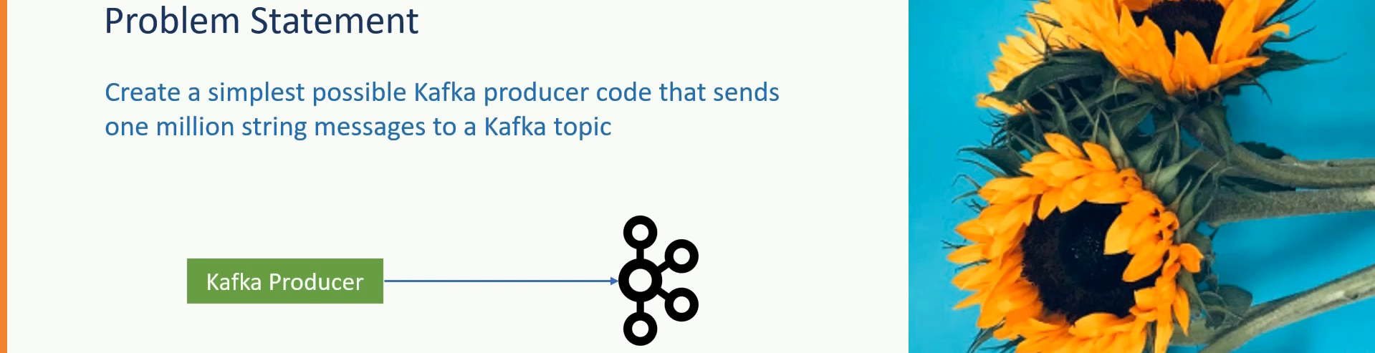
3. Download the attached project and import into the intellij.
   1. **02-hello-producer-starter.zip**: Initial project.
   2. **02-hello-producer-completed.zip**: Complete project with code.
4. 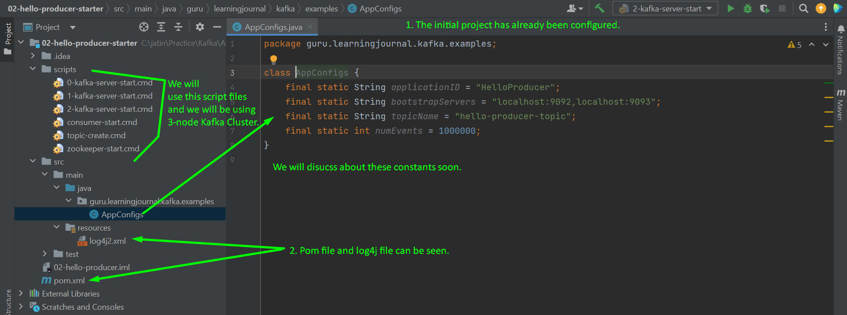
5. 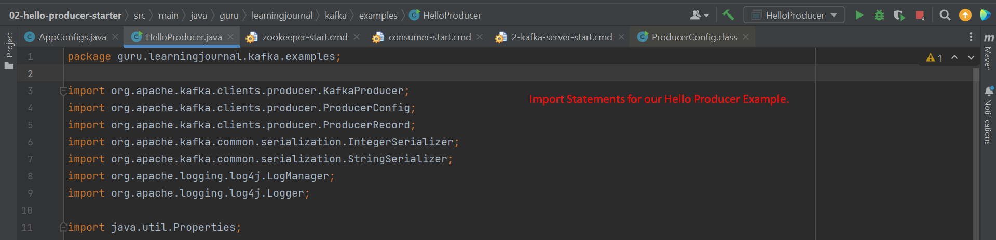
6. 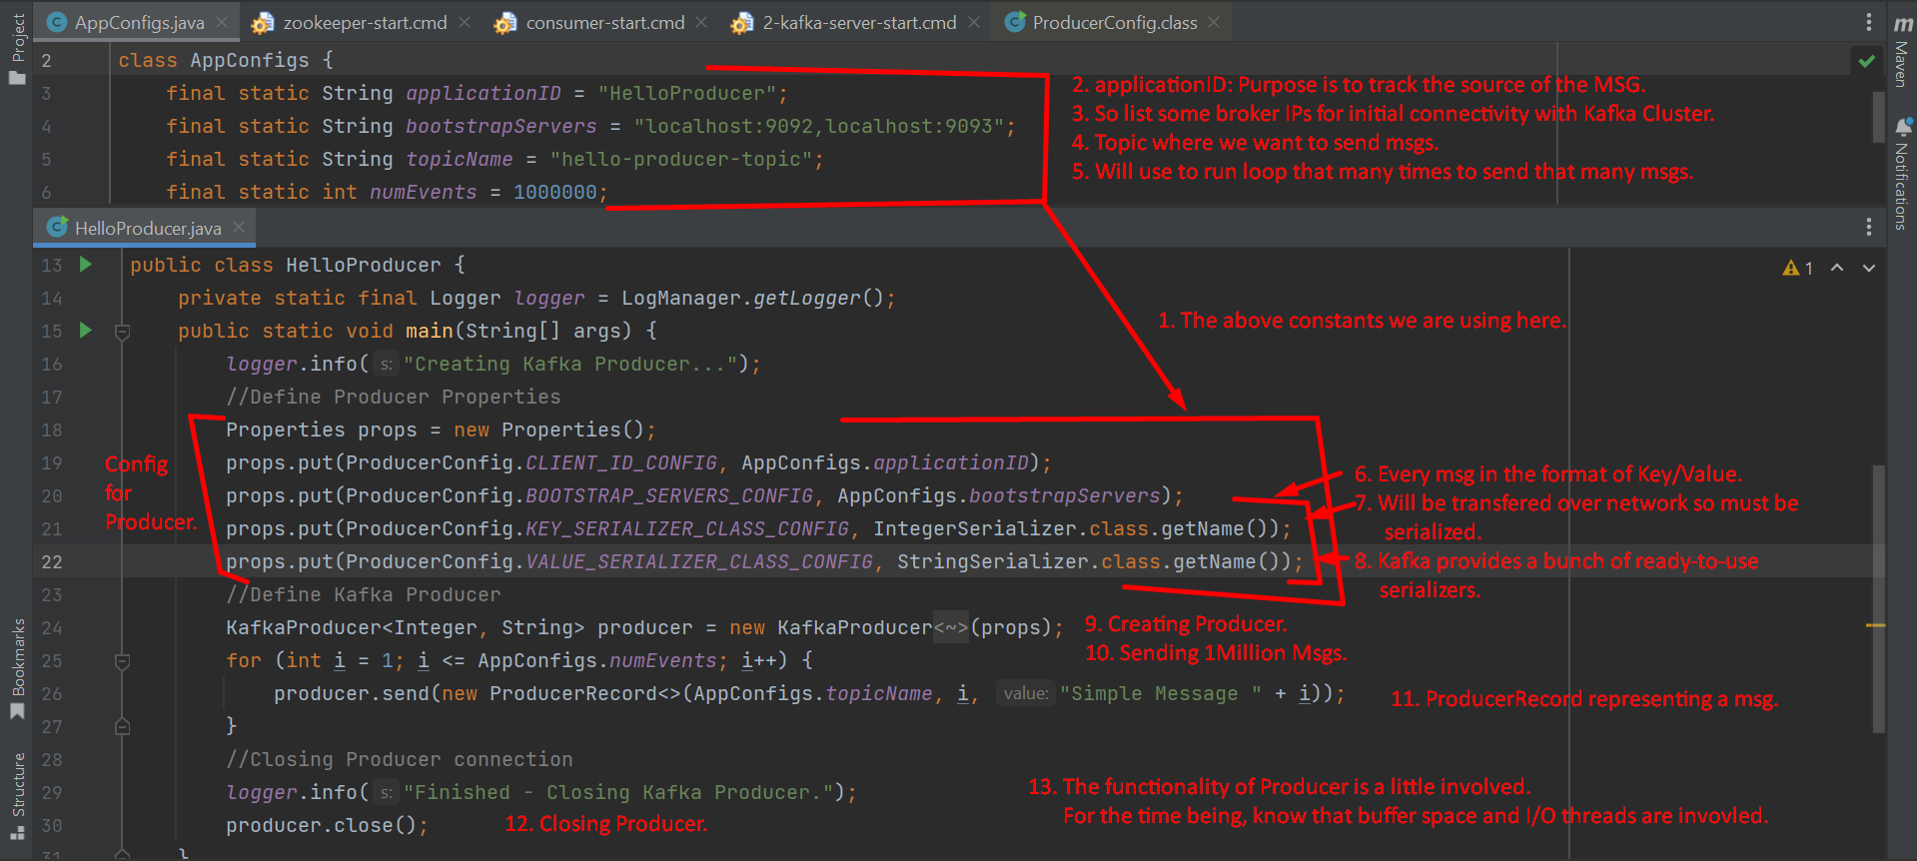

31. Producer Record

1. ProducerRecord.java 🡺 Wrapper around a kafka msg to be sent over network to kafka cluster.   
     
   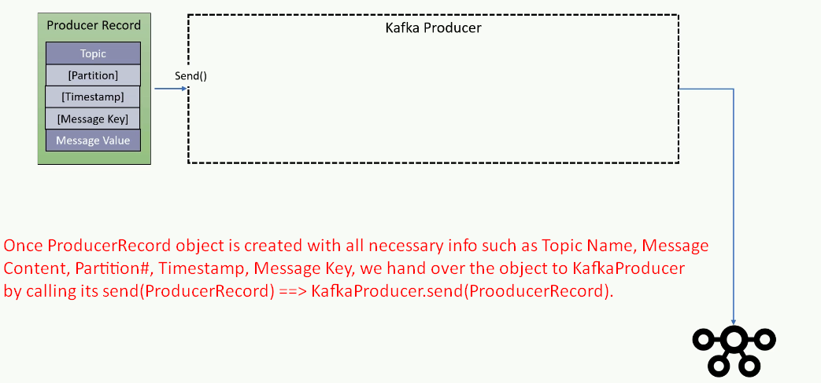

32. Producer Serializer

1. 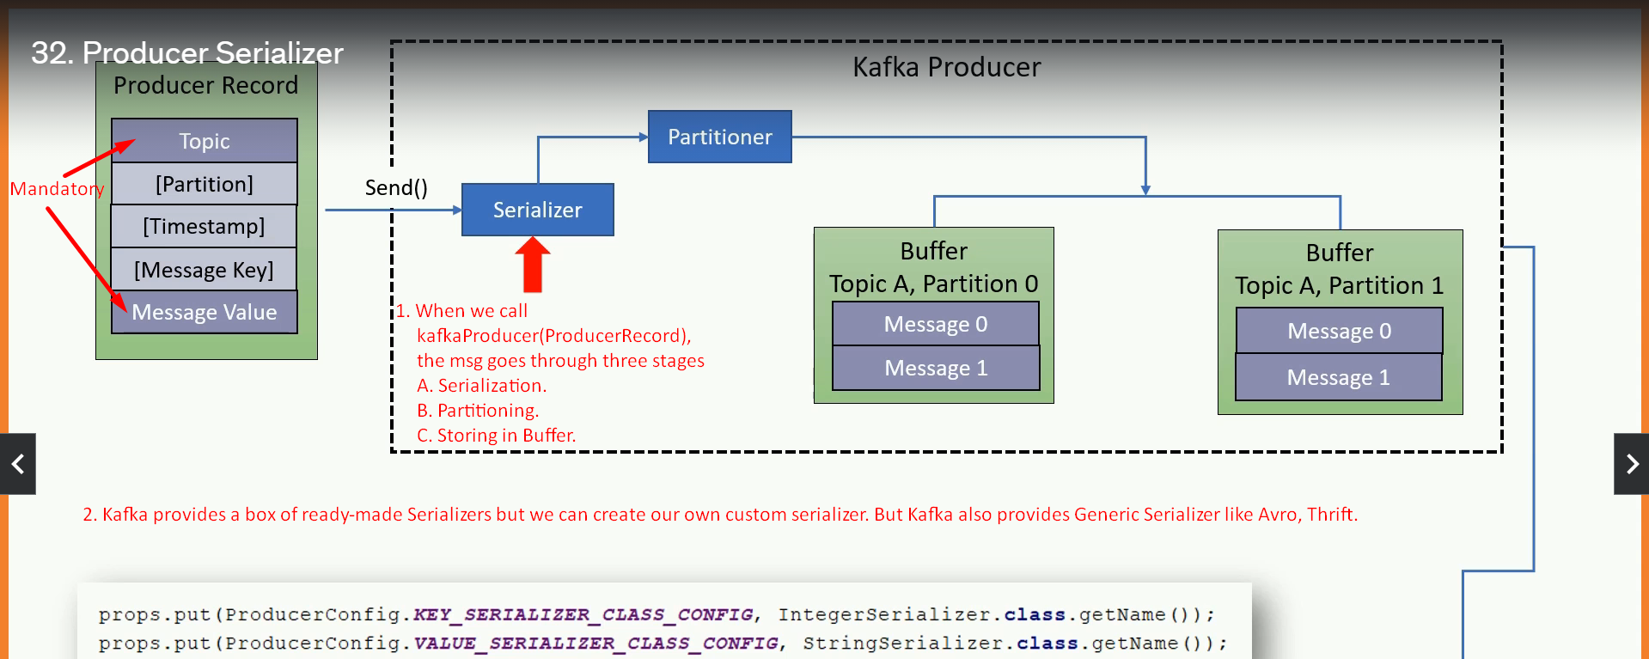

34. Message Timestamp

1. ProducerRecord.timestamp will be set either on the producer side or kafka broker side.
   1. **Create Time**: When msg is produced, timestamp is set by developer or producer api.
      1. set topic configuration 🡺 **message.timestamp.type** = 0
   2. **Log Append Time:** When msg is appended to a log file on broker side.
      1. **message.timestamp.type** = 1 (default)

35. Producer Message Buffer

1. Once msg is serialized and its destination partition is confirmed, the msg sits in buffer as KafkaProducer object has partition-wise buffer (as topic is passed as configuration to KafkaProducer).
2. Two reasons for Buffering:
   1. **Asynchronous**: To make KafkaProducer.send(ProducerRecord) asynchronous.
   2. **Network Optimization**: Background I/O thread can combine multiple msgs from the same buffer specific to a partition to make data packet to send over network for optimization.
3. 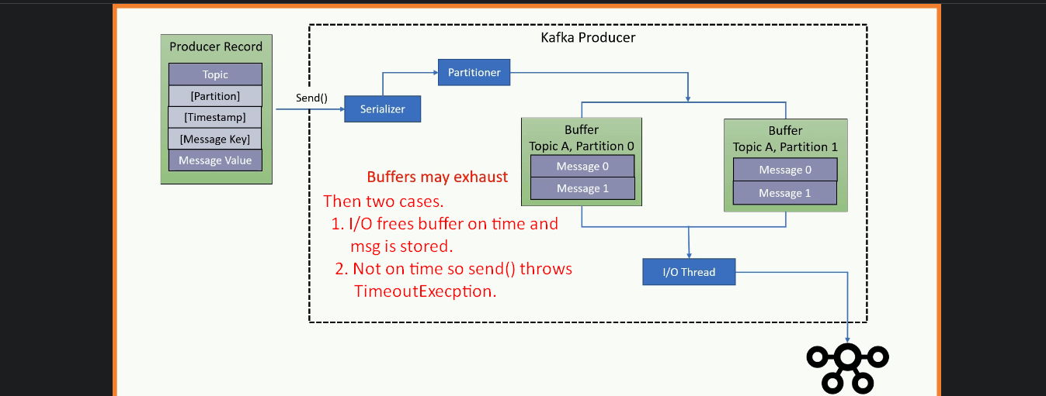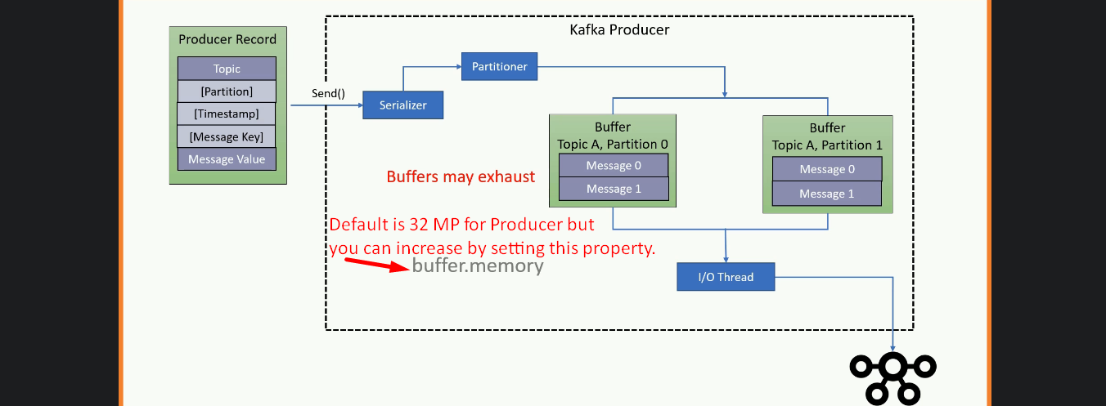

36. Producer IO Thread and Retires

1. properties.setProperty(ProducerConfig.RETRIES_CONFIG, Integer.toString(Integer.MAX_VALUE));

40. Creating Multi-Threaded Kafka Producer

1. 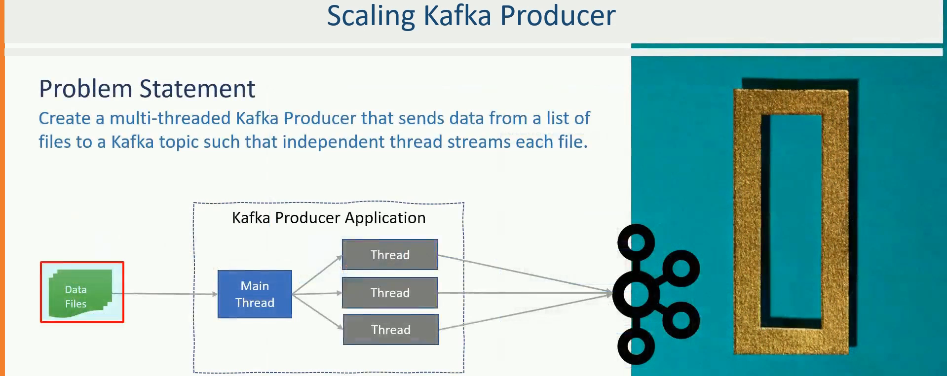
2. Basically, for each file, we will create a separate thread.
3. Some useful constants.  
   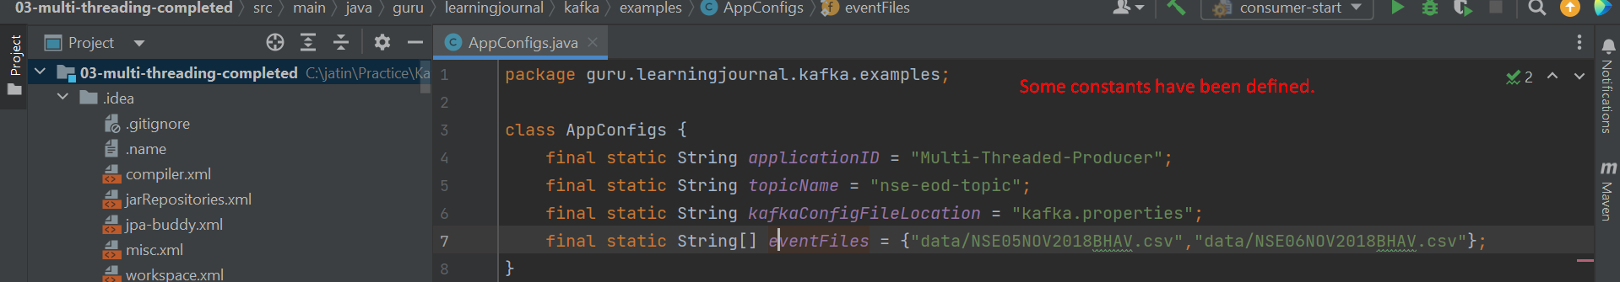
4. The following Runnable class where each runnable will be responsible to read from a file and sends lines as msgs.  
   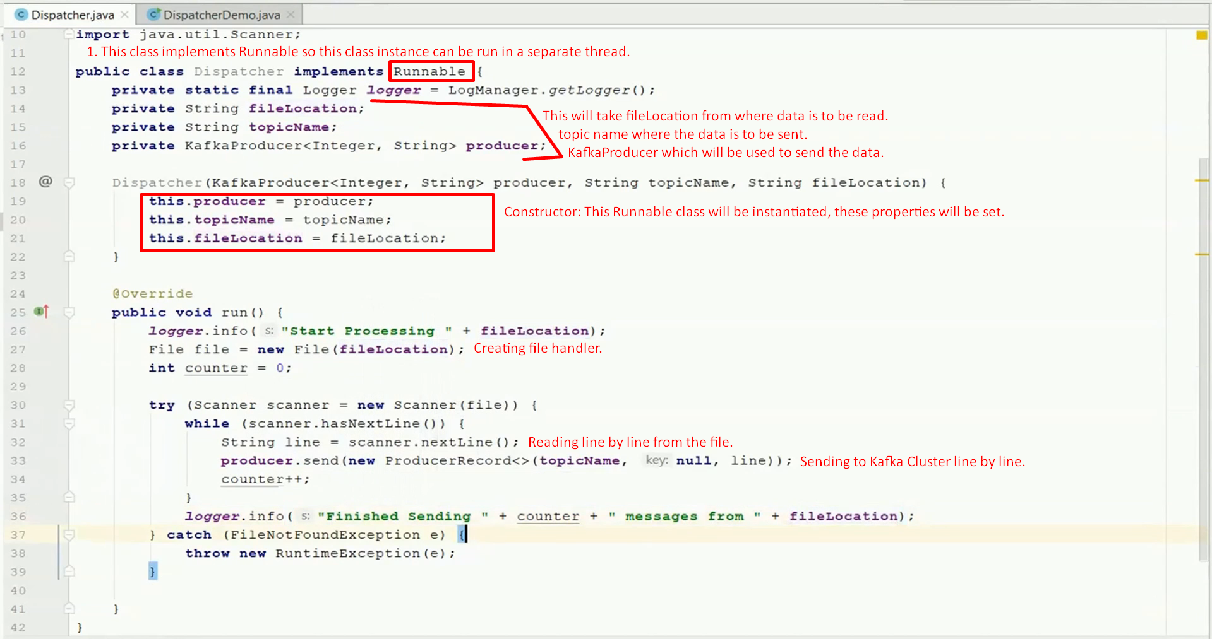
5. The following is the main() creating and starting multiple threads based on # of files.

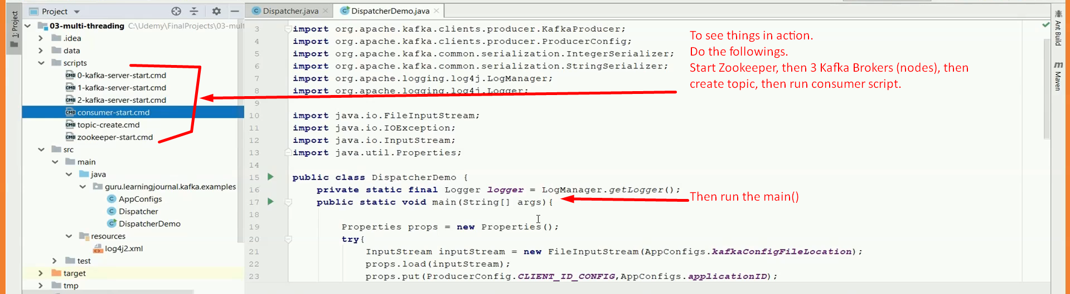

1. 

41. Atleast Once Vs. At Most Once

1. 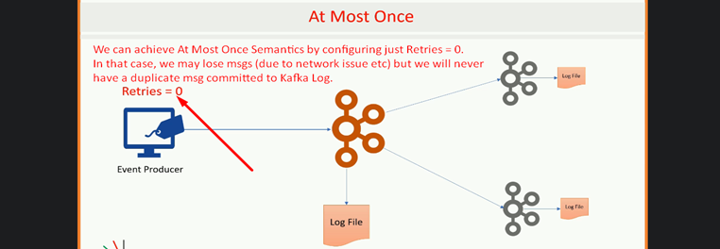

42. Exactly Once - Producer Idempotence

1. **enable.idempotence=true**
2. 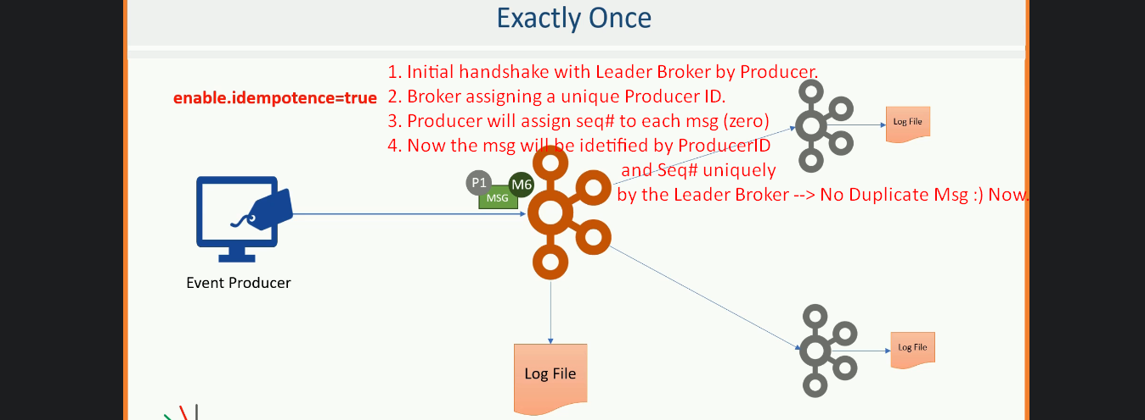

43. Transactions in Kafka Producer

1. We will send msgs to two topics to see the working of transaction one working and other rolling back.
2.   
   Let’s do the above in topic creation script.  
   
3. Some useful constants.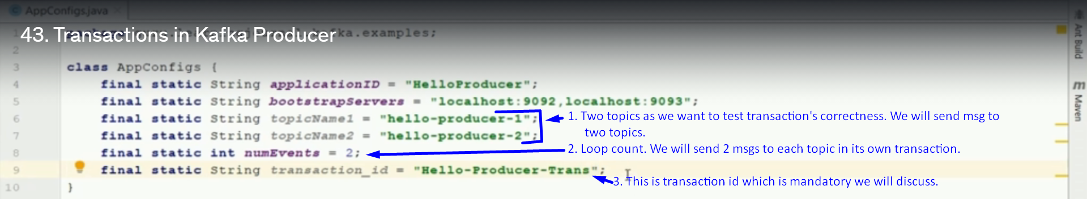
4. When we set TRANSACTIONAL_ID_CONFIG, idempotent is automatically enabled as transaction depends on idempotent.  
   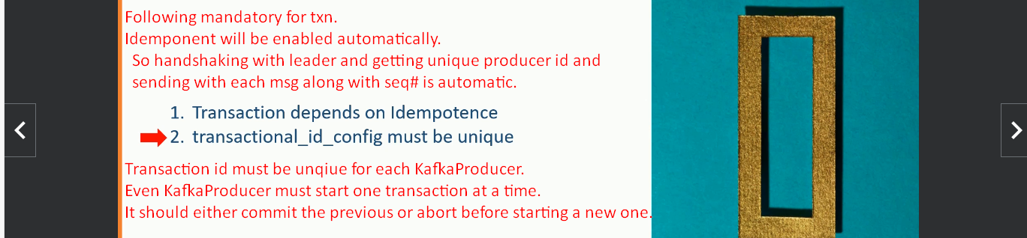
5. 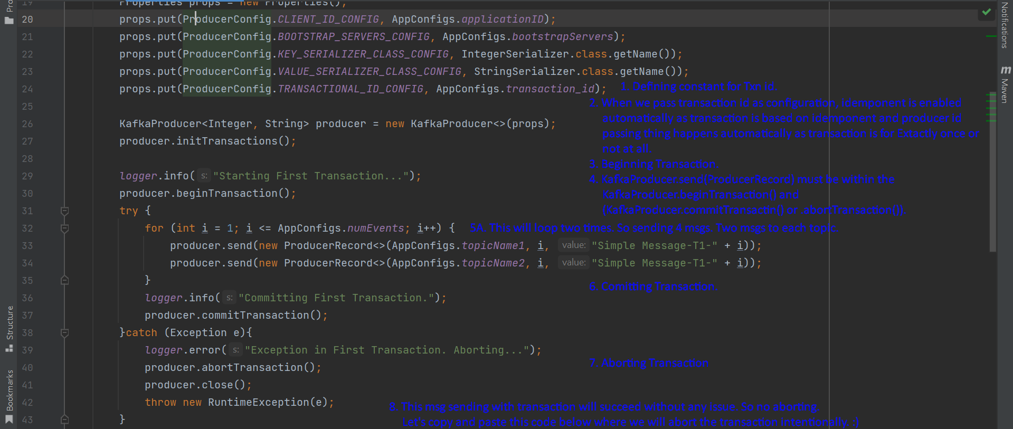  
   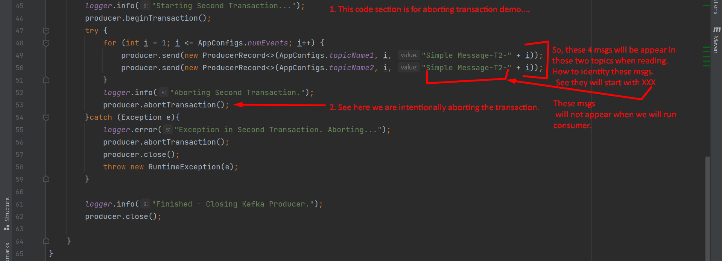
6. 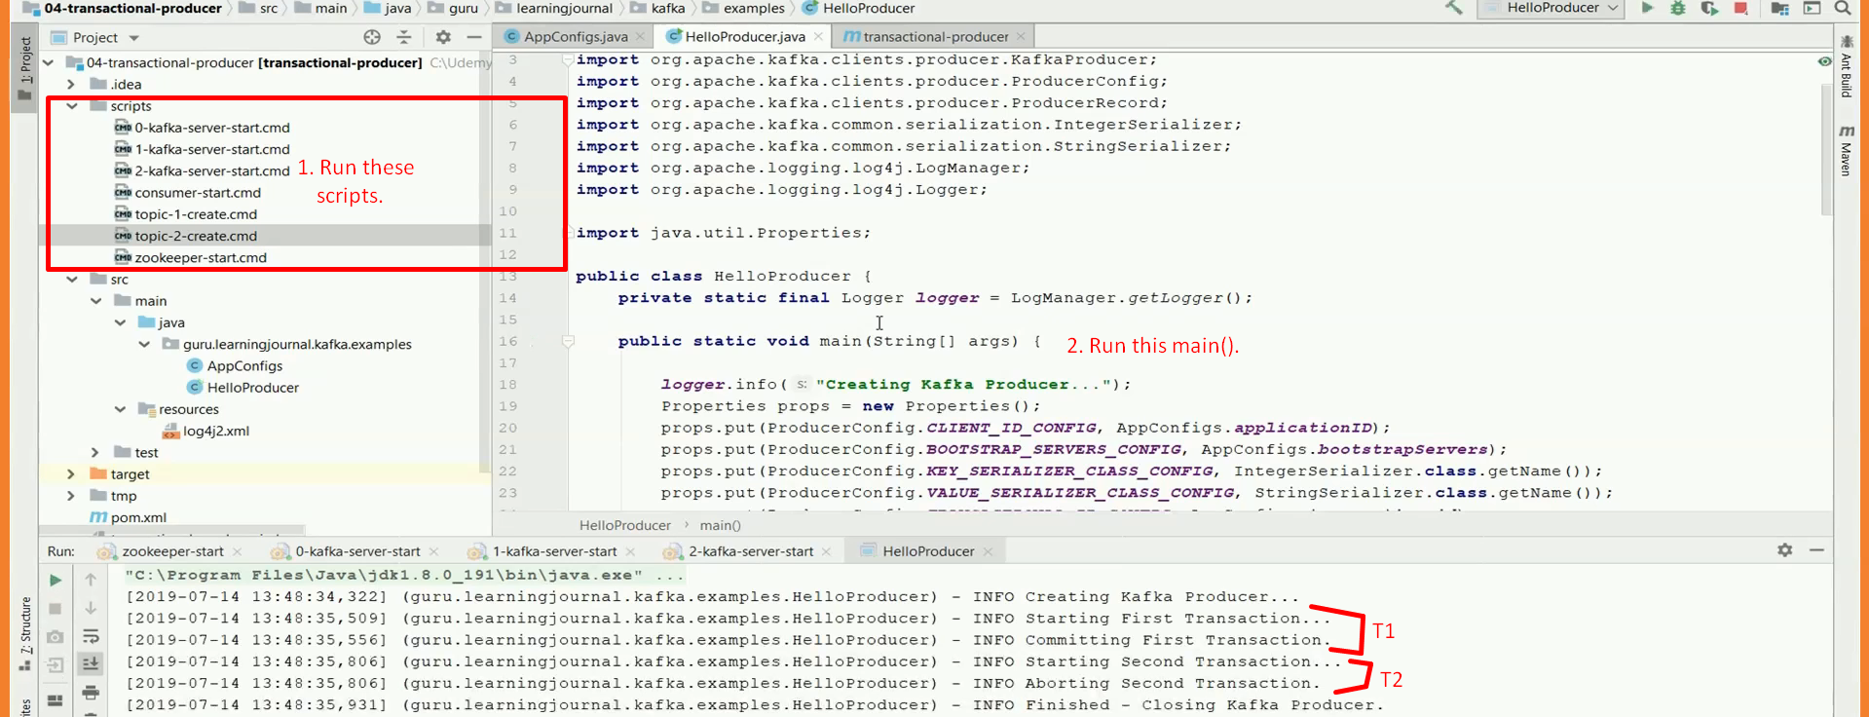
7. 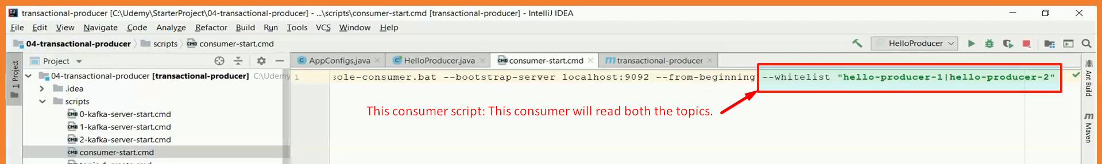  
     
   One final note about the transaction.
8. 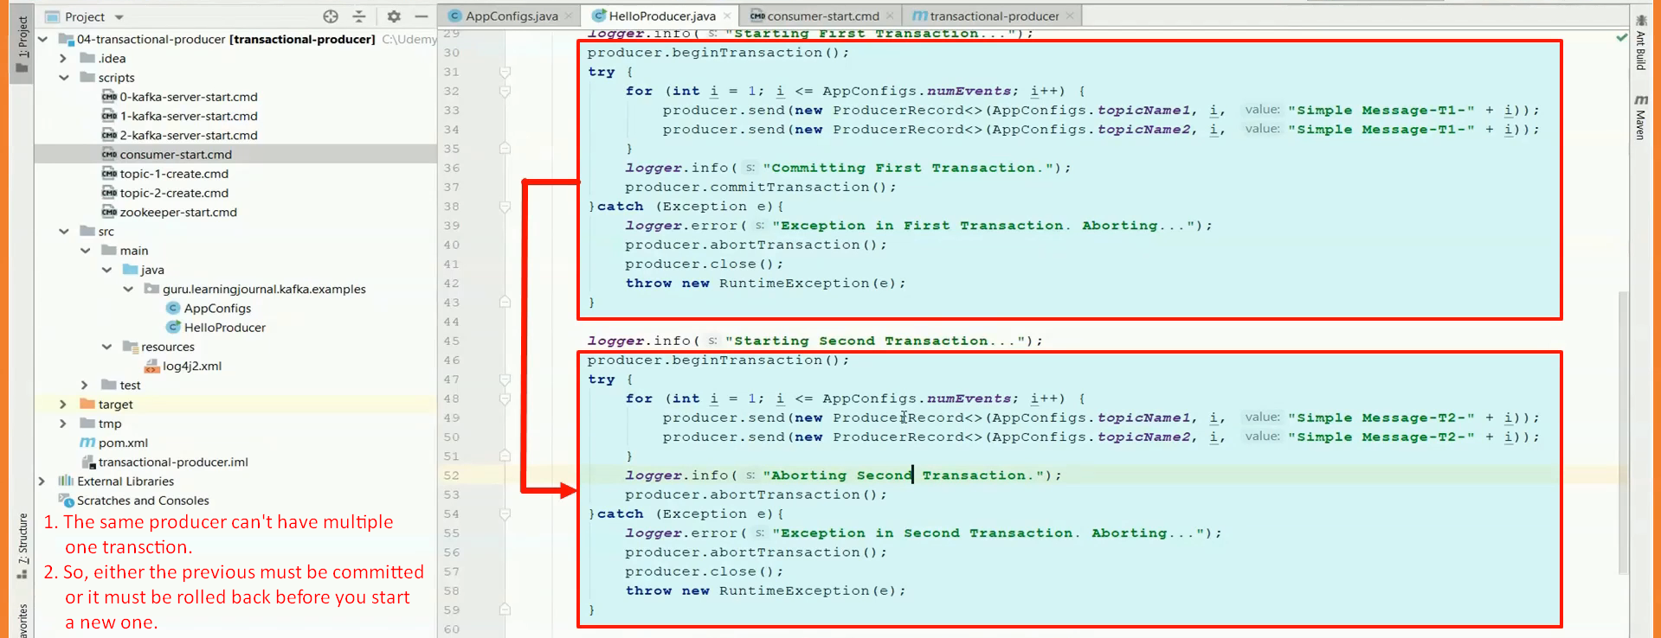
9. The below snapshot says that the next transaction should start when the previous one is either committed or aborted. Other case is not allowed.  
   
10. In multi-threaded producer, you will call send() from different threads.  
    So, before you run any thread, create transaction then start all the threads then when all the threads are done, commit or rollback the transaction.  
    Like if main() is running 3 threads then main will begin transaction and will run the 3 threads and all the threads will join the main() and when 3 threads are done, the main thread will either commit or rollback the transaction.